Open the "Foodmart_Data_Model.xlsx" worksheet that you saved on your desktop. This file was the finished product of your previous exercises. You should first complete all the other exercises and Quests before this one.

Highlight cell A:1, and then click Power Pivot > Manage > Data View

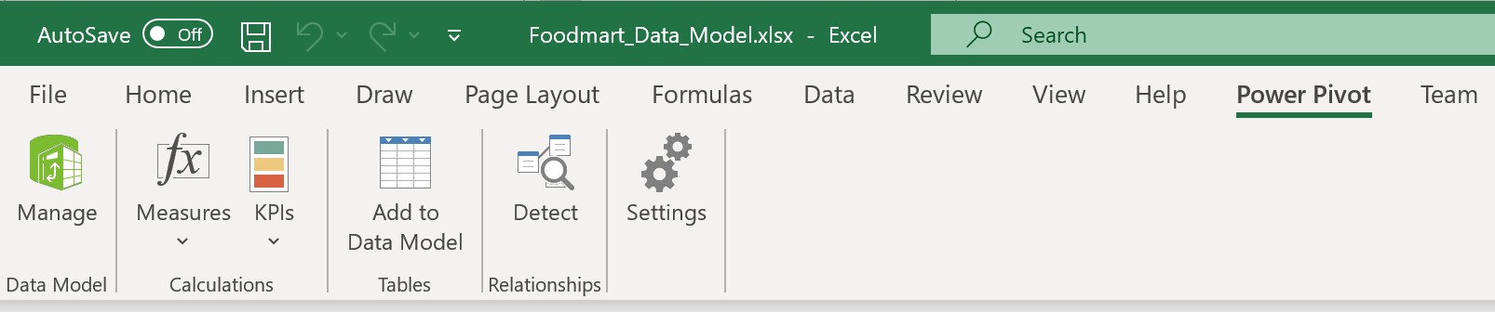



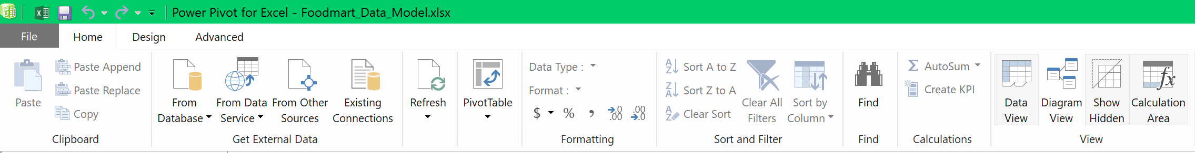



Home tab > dropdown of PivotTable > PivotTable

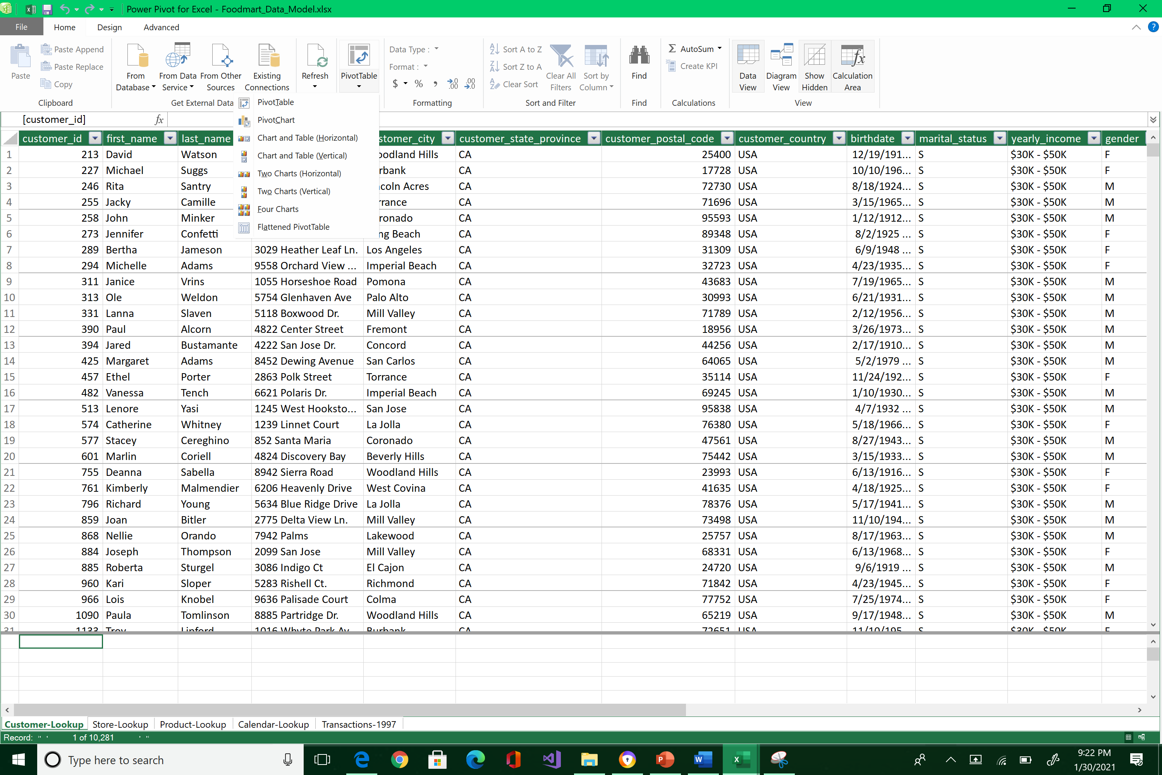



Put it in an Existing Worksheet and press OK

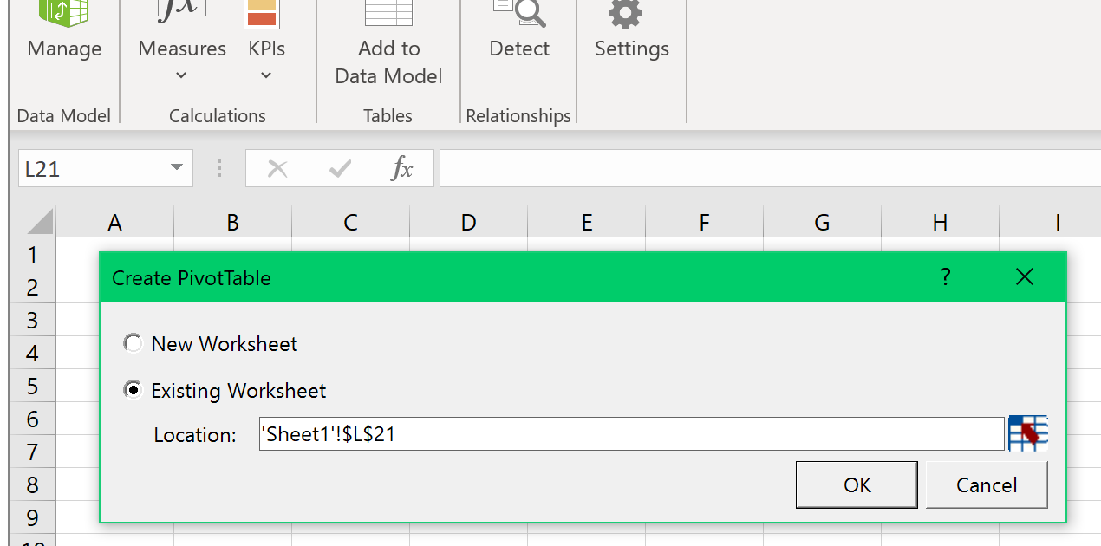



Welcome to Power Pivot! Note the following: When my cursor (hence active cell) is inside the Pivot Table area, the Pivot Table Fields window is displayed.

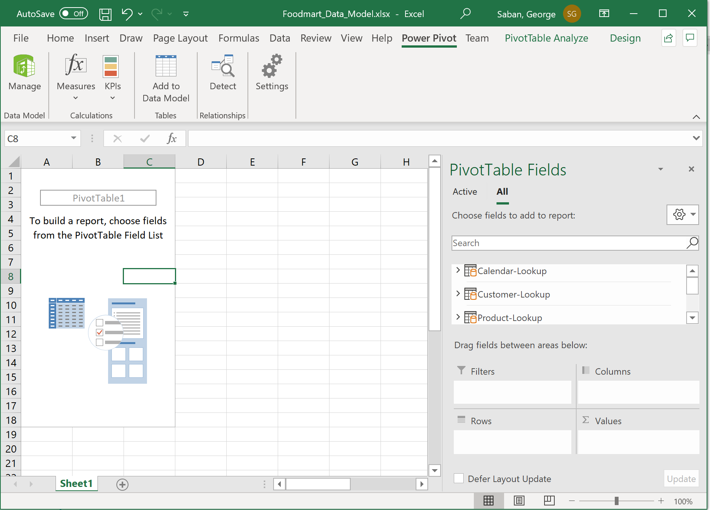



However, if you placed your mouse outside of the Pivot Table area, the Pivot Table Fields window disappears. (See next page)



Also, note that your Pivot table is created in Sheet1: a new worksheet because that was what you opted for.

If you did not highlight cell A:1 at the beginning of this exercise, your Pivot Table would be created in a random location where your cursor was. If you don't like that position, you can highlight the Pivot Table area, cut it, and past it in cell A:1.

Finally, feel free to close your Queries box if it is open on your worksheet.

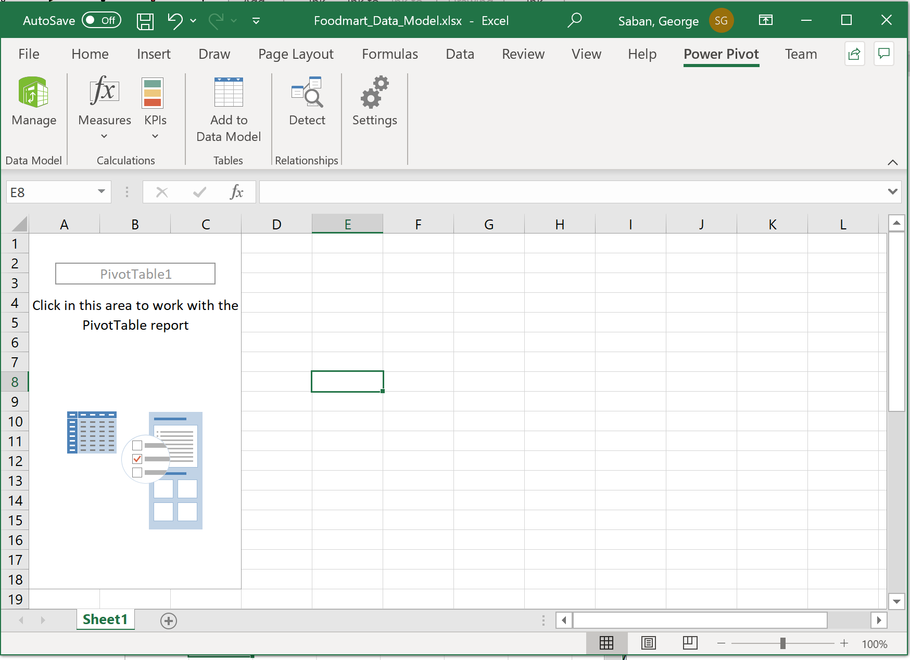



There is another way of opening a brand-new Pivot Table. Here are the steps:

* Deselect the current Pivot Table by putting your cursor outside of the current Pivot Table area.





Insert > Pivot Table

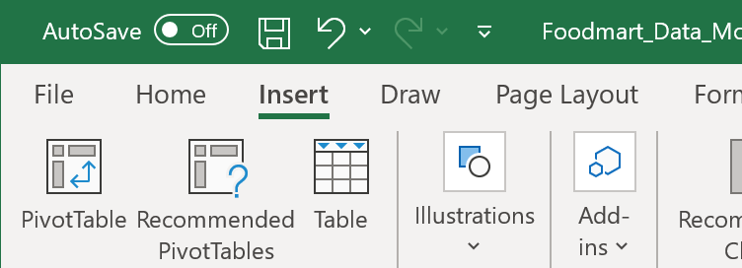



Select Use this workbook’s Data Model > New Worsksheet > OK

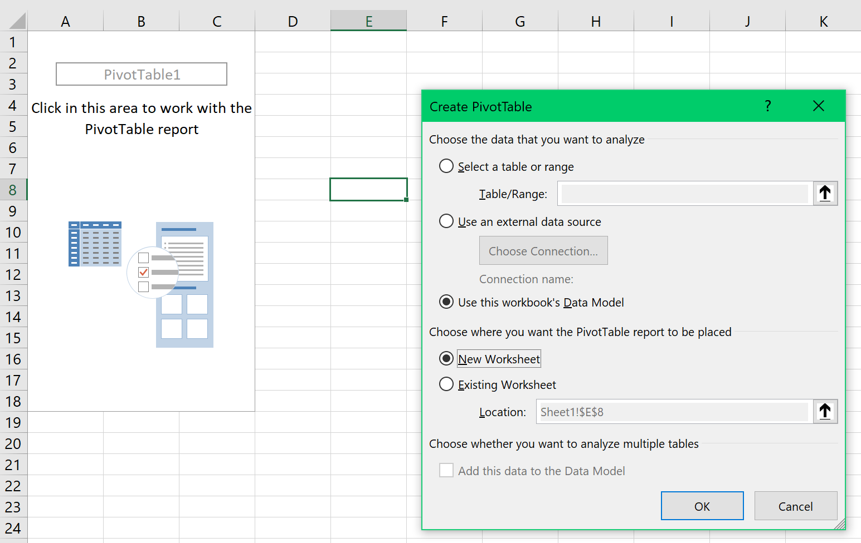



A Pivot Table is created in Sheet2 (a new worsksheet)

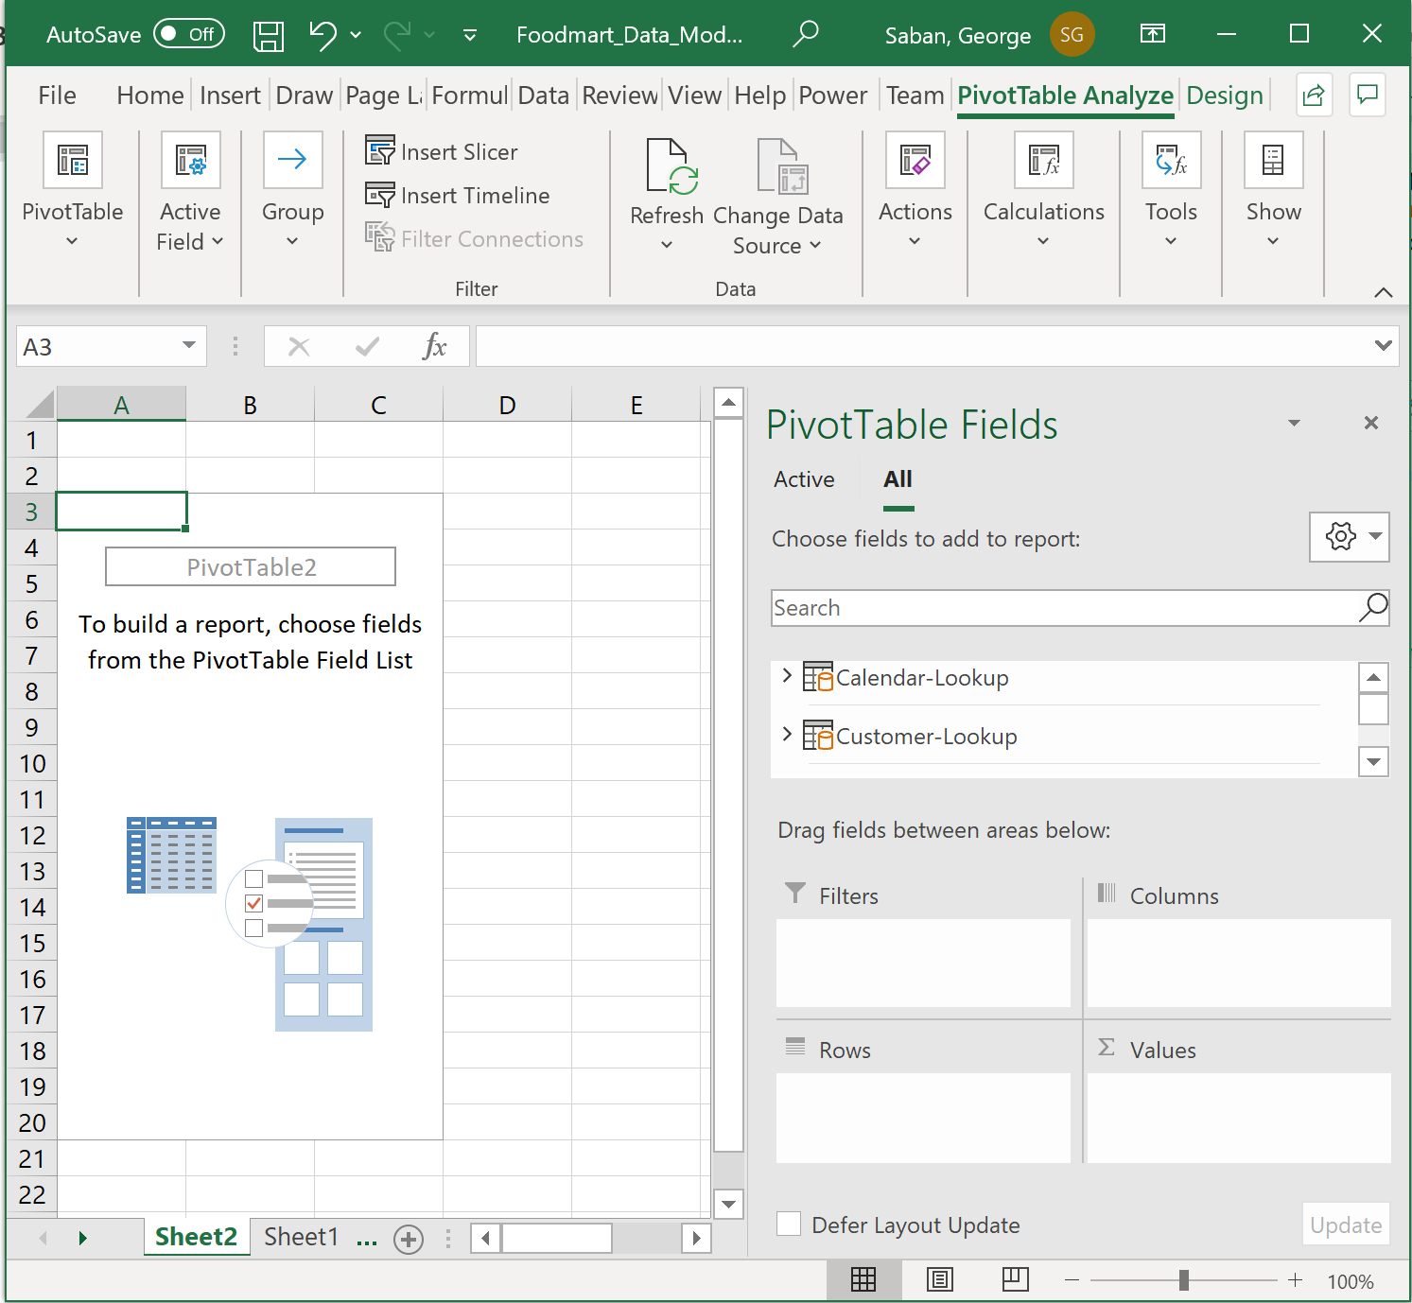

There you have it! You have now learned how to open Power Pivot in two different ways.

Reposition your screens so that the Power Pivot window is above the data model window.

1. Take a snapshot using Window's Snipping Tool.
2. Make sure the system's date, your name, and the two sheets are included in the image.
3. Submit to Canvas in PNG format.

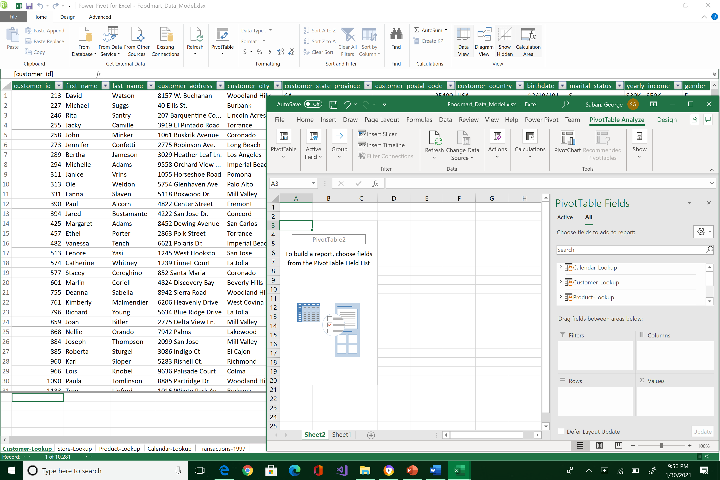



After submitting your work, delete Sheet2 because we only need one Power Pivot table: right click Sheet2 > Delete. Then save your work.

